23AI2003 –Artificial Intelligence for Web Development Lab
URK23CS5003

Ex. No: 1 | Online Event Registration & Promotional Portal Using HTML5 (Form + Media Elements)
09.12.2025

Aim

To design and develop an Online Event Registration & Promotional Portal using HTML5 that demonstrates the use of form elements and media elements such as images, audio, and video.

Description

The portal allows users to view details of an upcoming event through HTML5 media elements (image banner, promotional video, background audio).Users can then register for the event using an HTML5 form with various input types (text, email, date, radio buttons, select menus, textarea, file upload).

This experiment demonstrates the integration of multimedia content and interactive form elements in a modern HTML5 webpage.

Code
<!DOCTYPE html>
<html lang="en">
<head>
<meta charset="UTF-8">
<title>Music Concert Registration</title>
<meta name="viewport" content="width=device-width, initial-scale=1.0">
</head>

<body>
<h1> Live Music Concert 2026 </h1>
<h2>Register Now!</h2>
<!-- Event Banner Image -->
<img src="banner.png" alt="Music Concert Banner" width="100%">

<br><br>
<!-- Promotional Video -->
<h3>Watch Our Promo Video</h3>
<video width="600" controls>

<source src="promotional.mp4" type="video/mp4">
Your browser does not support the video tag.
</video>
<br><br>

<!-- Intro Audio -->
<h3>Concert Intro Music</h3>
<audio controls>
<source src="Intro.mp3" type="audio/mpeg">
Your browser does not support the audio tag.
</audio>
<hr>
<!-- Registration Form -->
<h2>Music Concert Registration Form</h2>

<form action="#" method="post">

<label>Full Name:</label><br>
<input type="text" name="fullname" required><br><br>

<label>Email Address:</label><br>
<input type="email" name="email" required><br><br>

<label>Date of Birth:</label><br>
<input type="date" name="dob" required><br><br>
<label>Gender:</label><br>

<input type="radio" name="gender" value="Male" required> Male
<input type="radio" name="gender" value="Female"> Female
<input type="radio" name="gender" value="Other"> Other
<br><br>

<label>Ticket Type:</label><br>
<select name="ticket" required>
<option value="">--Select Ticket Type--</option>
<option value="General">General</option>
<option value="VIP">VIP</option>
<option value="Backstage">Backstage Pass</option>
</select>
<br><br>

<label>Additional Comments:</label><br>
<textarea name="comments" rows="4" cols="40"></textarea>
<br><br>

<label>Upload ID Proof:</label><br>
<input type="file" name="idproof" accept=".jpg,.png,.pdf" required>
<br><br>
<input type="submit" value="Register">
</form>
</body>
</html>

Input & Output
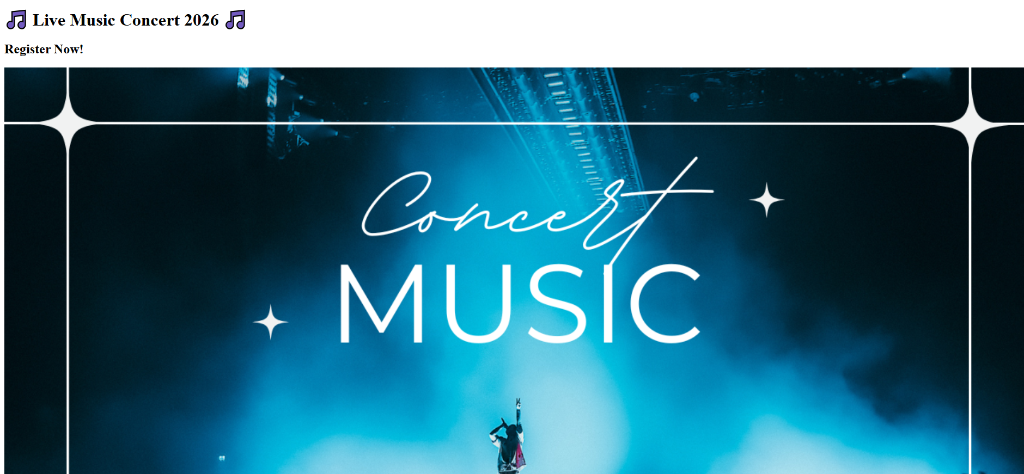
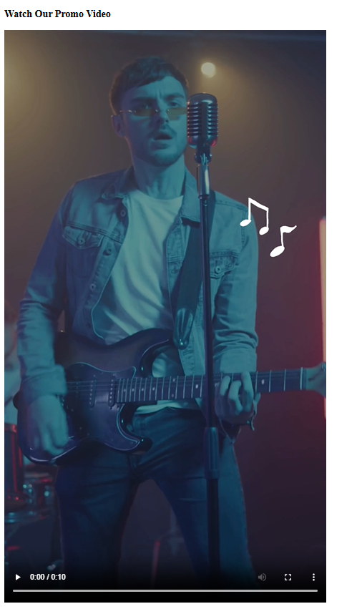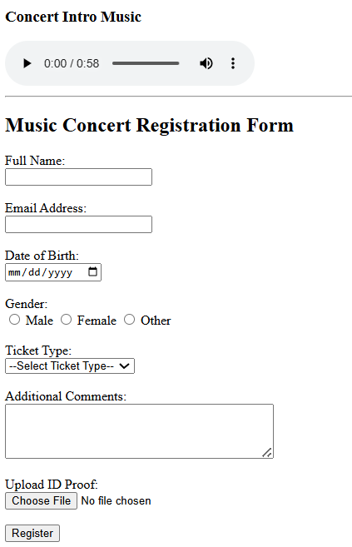

Result
The experiment was successfully completed.

